Conductivity Sensor Tutorial/troubleshooting

# Probe

The probe for the conductivity sensor is 3-D printed out of ______. It is the only part of the sensor which should be immersed in water.

## Manufacturing

### Parts list for the probe:

|  |  |  |  |
| --- | --- | --- | --- |
| Part | Amount | Notes | Image |
| 3D printed probe | 1 | stl file for 3D printing can be found in the Dropbox at: "SeeBoat\Talia\Conductivity\Hardware\probe 2.0.STL" |  |
| Single-core wire | 2 | Any single core wire should work, a relatively thin one will be easier to attach. |  |
| 6-32 ½” screws | 2 | These screws fit the holes in the probe CAD snugly, so they will be the easiest to install. |  |
| 6-32 ½” nuts | 2 | These are the corresponding nuts. |  |
| MG Chemicals epoxy | 1 | Part number: 832TC-450ML  <https://www.amazon.com/MG-Chemicals-Thermally-Conductive-Encapsulating/dp/B008UH4CRM#product-description-iframe> |  |

### Steps:

1. 3D-print the probe using the stl file in the Dropbox folder mentioned above.
2. Gather other materials according to the parts list.
3. Tighten the screws in place, using the nuts. Do not tighten all the way yet.

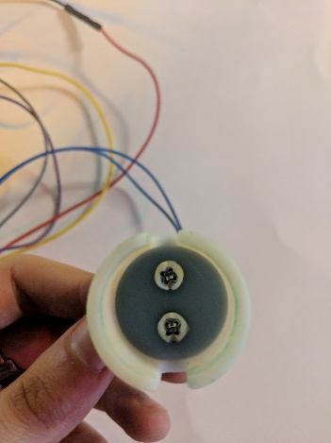

The head of the screws should be facing as shown above.

1. Carefully wrap exposed wire around each end of the screw, then tighten the nuts on all the way so that the wire is securely clamped down by the nuts.
2. Follow the directions on the epoxy containers to waterproof the probe. The epoxy should cover the threads of the screws and up the wires a little bit.

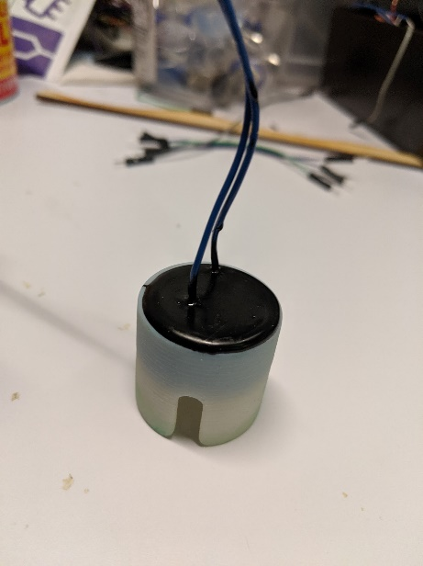

The cured epoxy (black) should look like this.

1. Connect the ends of the wires to the appropriate pin on the circuit board.

# Circuit Board

The circuit board has a lot of small parts and assembling requires a good amount of patience. Take your time!

## Manufacturing

### Parts list for the circuit board:

|  |  |  |
| --- | --- | --- |
| Symbol | Value | Part # (if applicable) |
| R1, R2, R3, R4 | 10 kΩ | YAG2122CT-ND, 0603 |
| R5 | 1 MΩ | YAG4498CT-ND, 0603 |
| R6, R7 | 1 kΩ | RNCP0603FTD1K00CT-ND, 0603 |
| R8 | 47 kΩ | 0603 |
| R9 | 4.7 kΩ | 0603 |
| R10 | 1.2 kΩ | 0603 |
| C2 | 0.1 μF | C1608X8R1H104K080AB, 0603 |
| D1, D2 | N/A | S1BBFDICTND |
| U1 | N/A | TLV2374IDR |
| U2 | N/A | TLE2426CLPR |
| IC1 | N/A | AD8655ARZ-REEL7CT-ND |
| S1 | N/A | 401-2013-1-ND |
| -- | N/A | custom circuit board |
| Header | N/A | WM9131-ND |

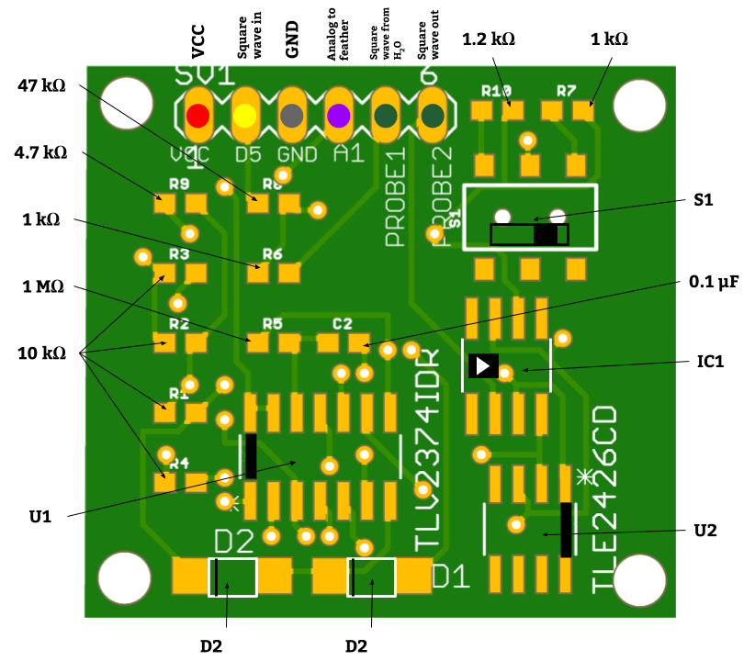

### Steps:

1. Collect all the parts you need to solder on a print-out of the above schematic (located in the Dropbox at: “SeeBoat\Talia\Conductivity\Hardware\Conductivity Board Diagram.docx”). It helps to tape them to their corresponding labels so you don’t mix them up.
2. Solder each part onto the board.

NOTE: **Some of the parts have directionality to them, so make sure you have them oriented the right way. Also, it helps to start adding parts from the middle and then work your way to the edges.**

1. Solder the wires which connect to the Feather into header. The order in which you solder them is very important, so be sure to double check they match:

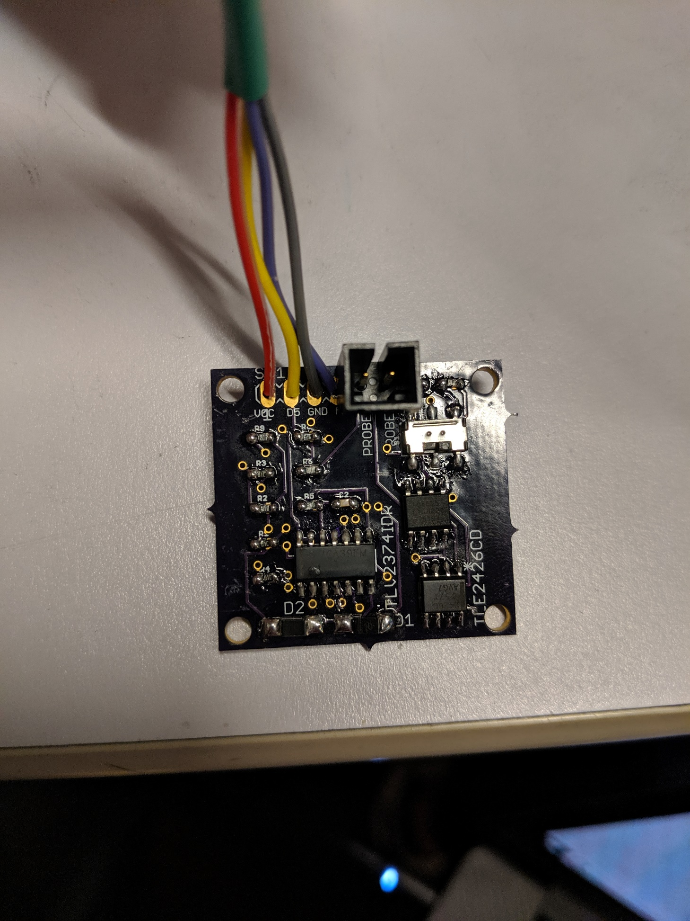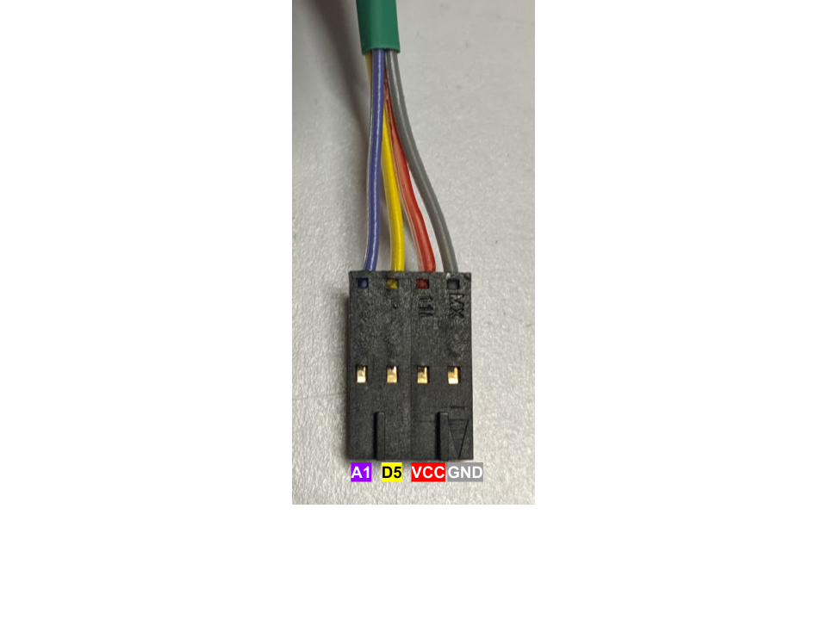

This is the correct ordering of the wires.

1. Solder the wires which connect to the probe into their pins.
2. Test it!

## Calibration

To calibrate the conductivity sensor, use the conductivity standards to map the voltage readings to the corresponding conductivities. You can see the past calibrations in the Voltage to Conductivity spreadsheet (located in the Dropbox at: " SeeBoat\Talia\Conductivity\Voltage to Conductivity.xlsx").

To measure the voltage, use the Arduino code in conductivity.ino (located in the Github at: "seeboat\software\testing\conductivity\conductivity.ino"). Change the code to output voltage instead of conductivity in the loop():

>> **Serial**.println(conductivity);

Change to:

>> **Serial**.println(voltage);

An example calibration:

|  |  |  |  |  |
| --- | --- | --- | --- | --- |
| **Voltage (V)** | | | | |
| **Conductivity (**μS/cm) | **Switch towards middle (1.2 k**Ω) | **Average Voltage** | **Switch towards edge (1 k**Ω) | **Average Voltage** |
| 50.14214171 | 0.01-0.02 | 0.015 | 0.01-0.02 | 0.015 |
| 100 | 0.01-0.03 | 0.02 | 0.01-0.02 | 0.015 |
| 700 | 0.08-0.10 | 0.09 | 0.06-0.08 | 0.07 |
| 843.4624552 | 0.15-0.16 | 0.155 | 0.14-0.15 | 0.145 |
| 2000 | 0.21-0.24 | 0.225 | 0.18-0.20 | 0.19 |
| 3000 | 0.38-0.41 | 0.395 | 0.27-0.28 | 0.275 |
| 7688.461729 | 0.92-0.93 | 0.925 | 0.77-0.78 | 0.775 |

Linear regression shows the relationship between the data:

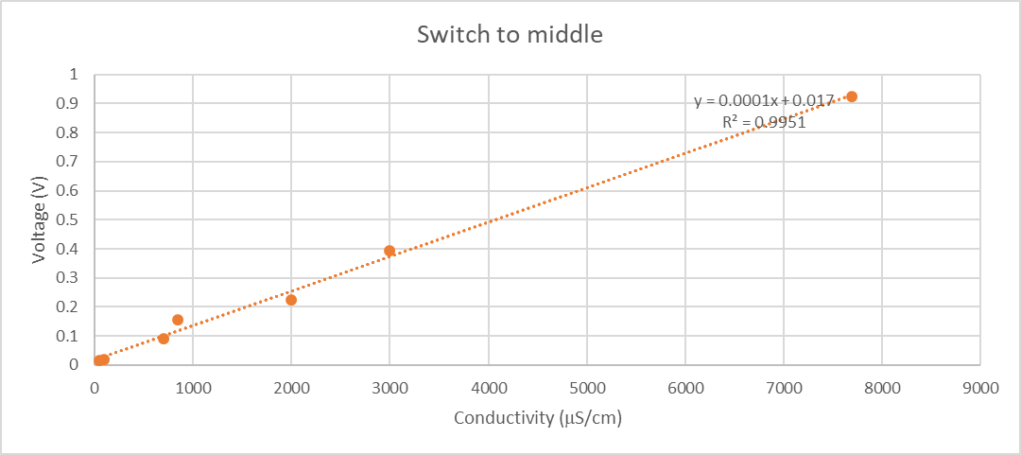

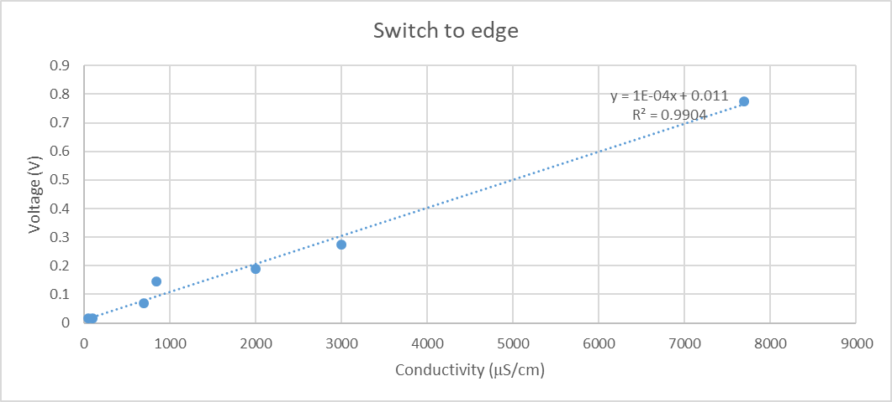

NOTE: **Some of the standards are in μS, some in μS/cm. To make sure all the units are consistent, multiply/divide by the cell constant. Our cell constant is approximately 0.5-1 cm-1.**

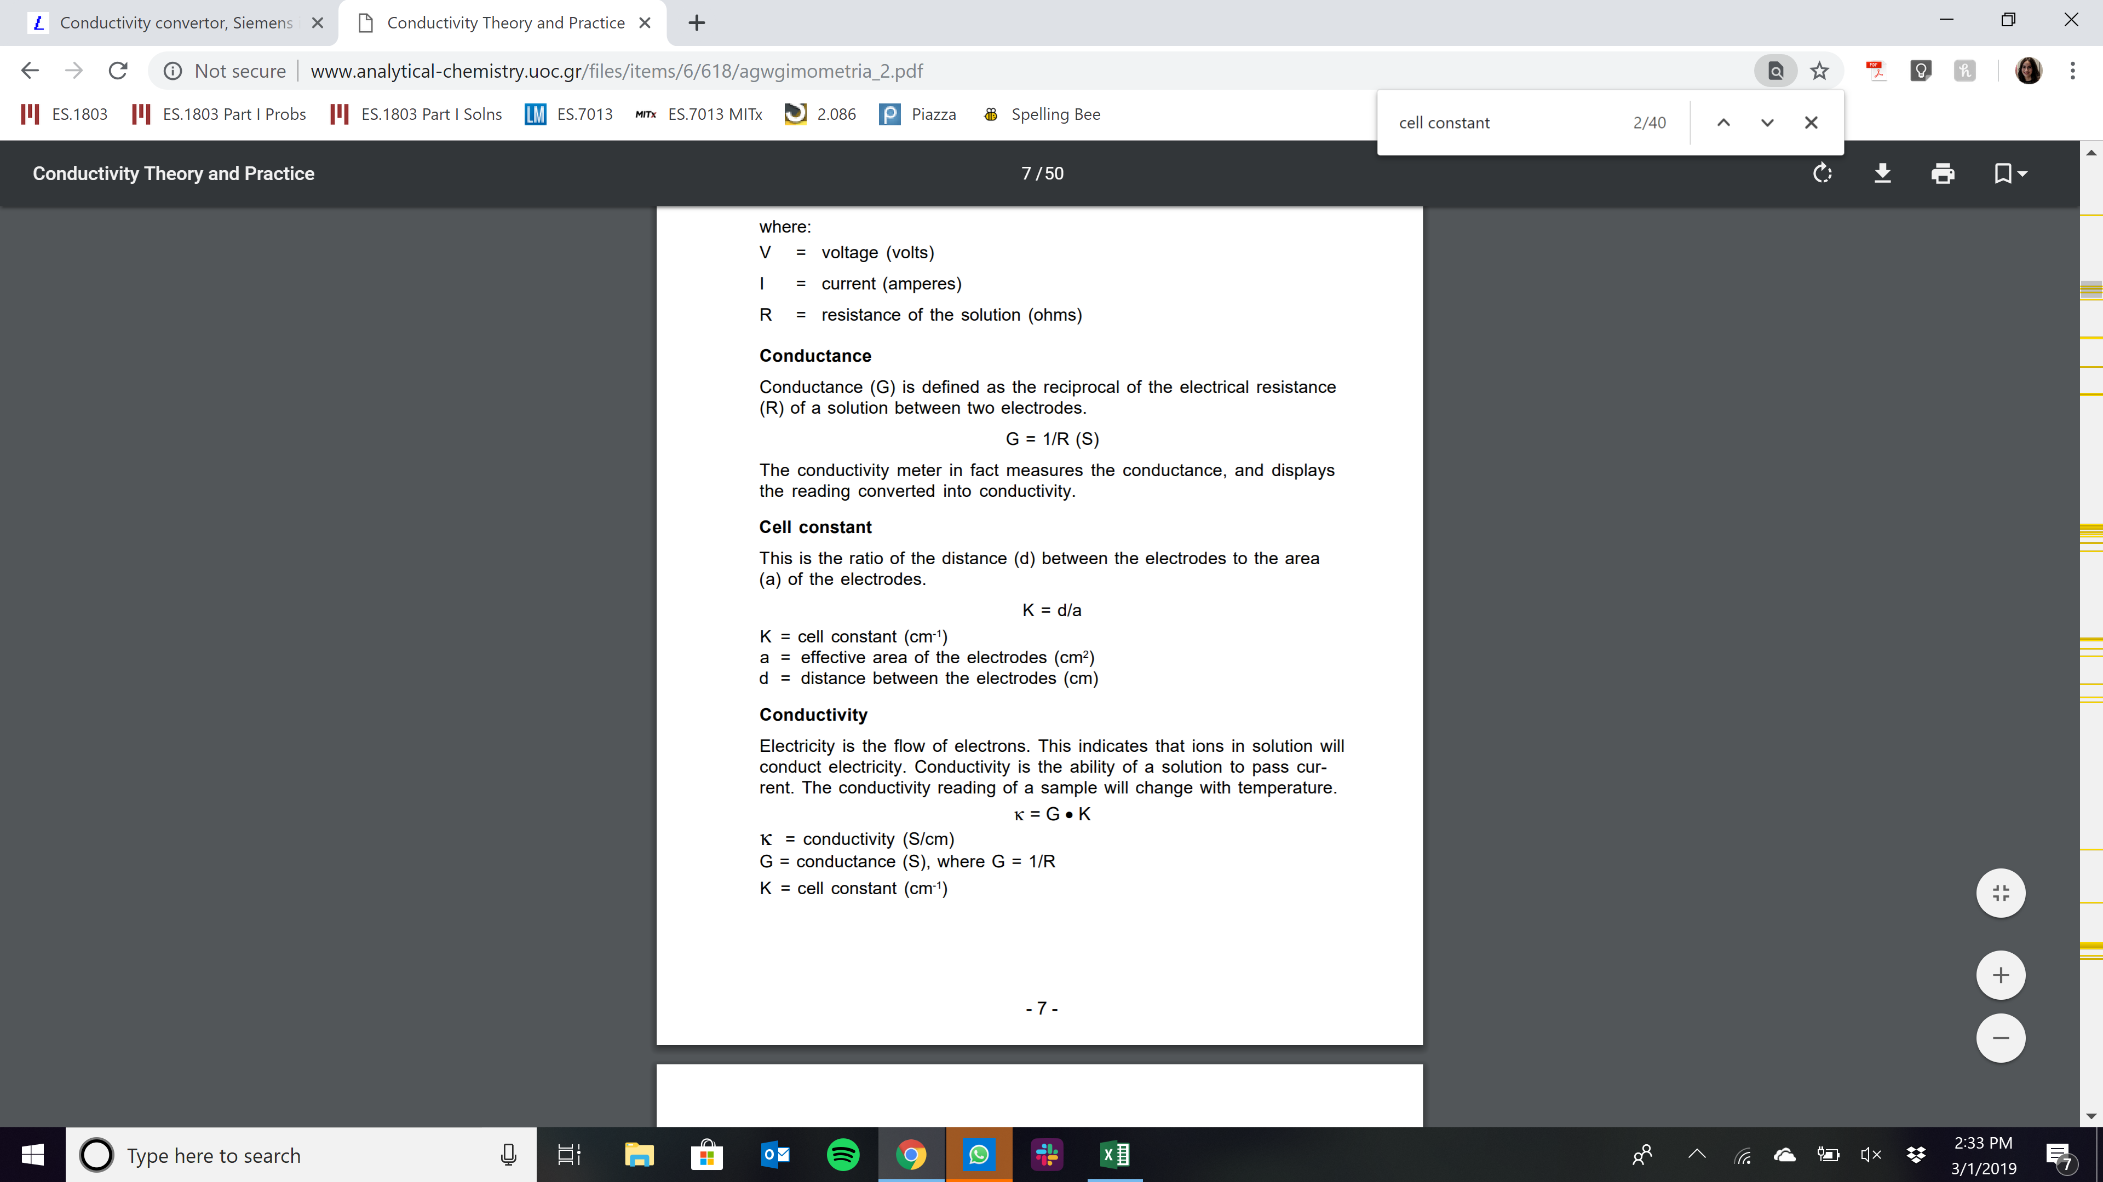

From: <http://www.analytical-chemistry.uoc.gr/files/items/6/618/agwgimometria_2.pdf>

# Troubleshooting

Troubleshooting the conductivity circuit board often involves using an oscilloscope. Follow the diagram below to debug what the problem might be:

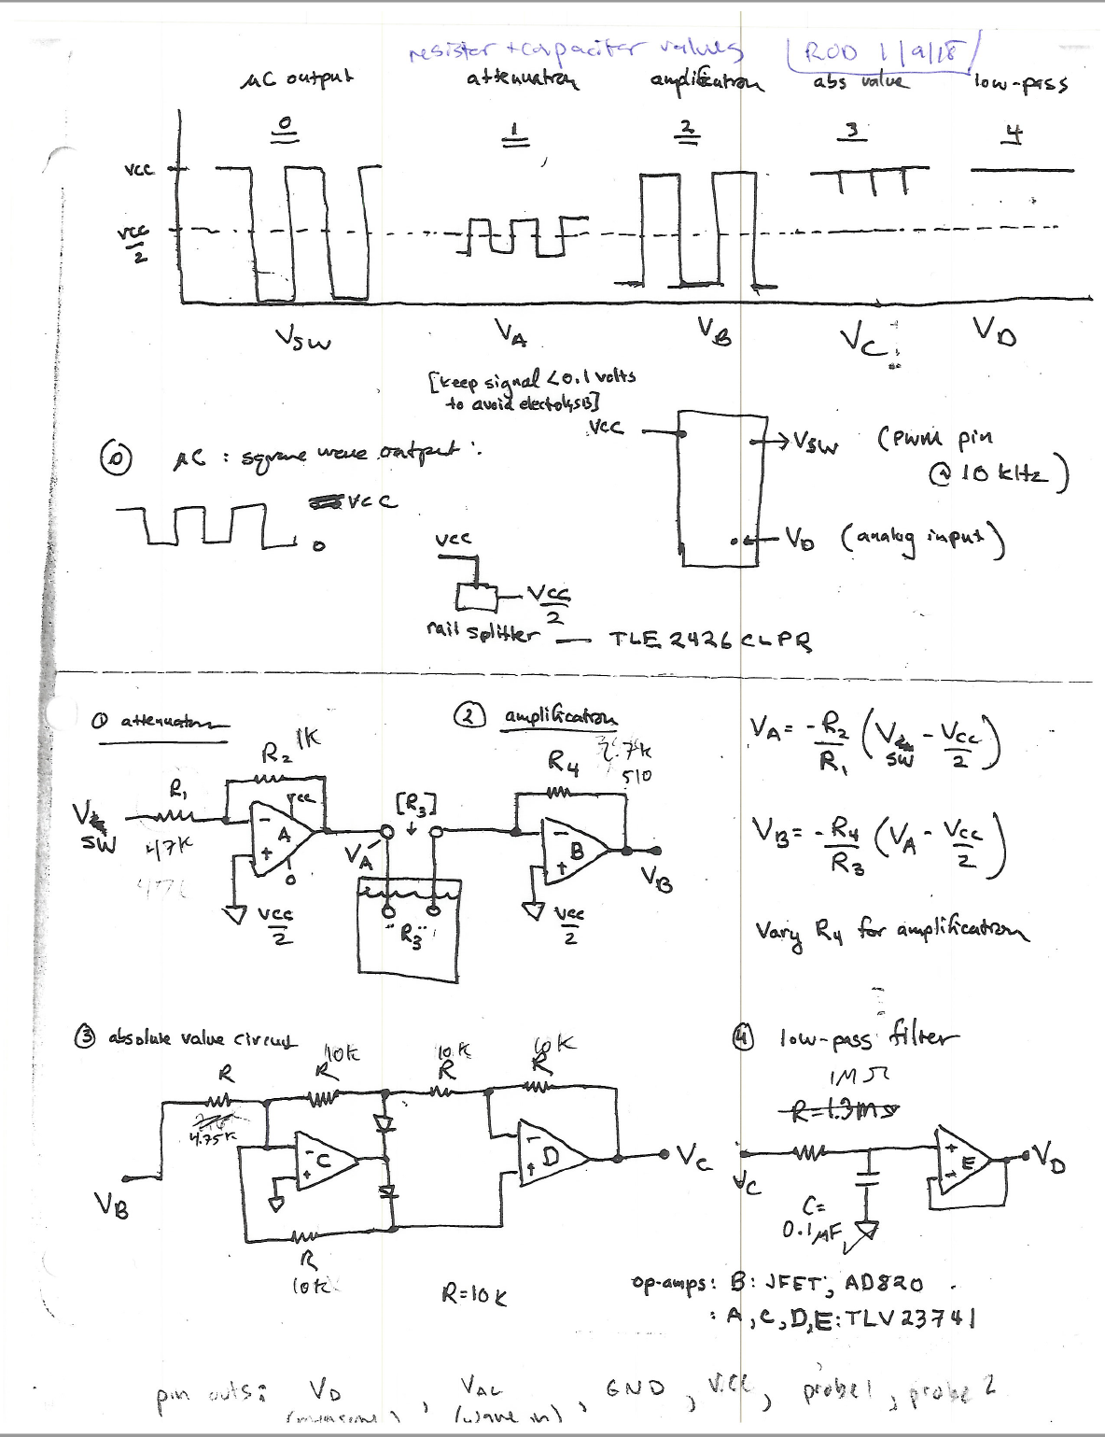

From: “SeeBoat\Talia\Conductivity\conductivityCircuitValues.pdf"